Nanjing University of Posts and Telecommunications


Title:Panorama Image Stitching Using ORB Feature Detection
School: College of Overseas Education
Student No: F23010116
Full Name: Aya Mesli
Submission Date: June 20, 2026
Lecturer: 戴文婷
Major: EIE

1. Introduction
Panorama image stitching is one of the applications of Digital Image Processing (DIP). It is used to combine multiple overlapping images into one wide image called a panorama image. Panorama stitching is commonly used in smartphone cameras, Google Street View, virtual reality, and photography applications.
In this project, Python programming language and OpenCV library were used to implement panorama image stitching using ORB feature detection. The system detects important feature points from overlapping images, matches the features between images, and combines them into one panorama image using geometric transformation techniques.
The main objective of this project is to study the basic concepts of panorama image stitching and apply Digital Image Processing techniques to generate a panoramic image from multiple overlapping images.

Implementation
First, two overlapping outdoor images were captured and loaded into the system using OpenCV library. The images contain common overlapping regions that are required for panorama stitching.
The original images were converted into grayscale images before feature detection. Grayscale conversion helps reduce computational complexity and improves feature extraction performance.
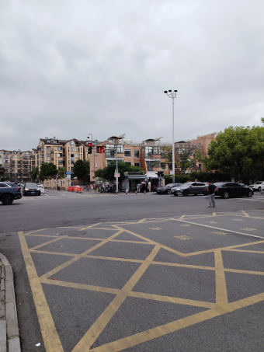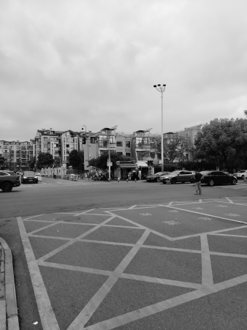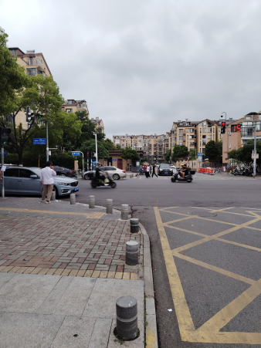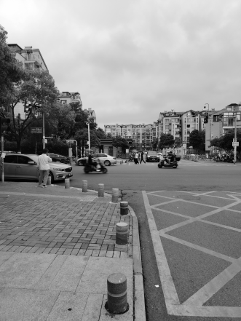
Original Image 1 Grayscale Image 1 Original Image 2 Grayscale Image2

Next, The ORB (Oriented FAST and Rotated BRIEF) algorithm was used to detect important key-points and descriptors from both images. ORB detects corners and texture regions that can be matched between overlapping images.
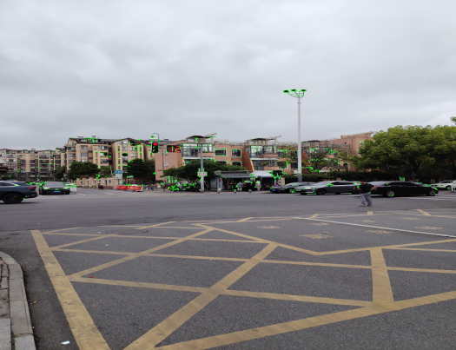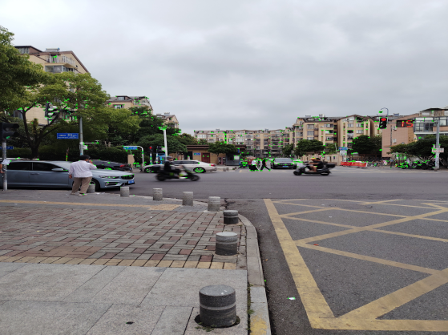
ORB Keypoint Detection
After detecting the keypoints, the BFMatcher algorithm was used to match similar descriptors between the two images. The matching points were used to estimate the homography matrix for image alignment.
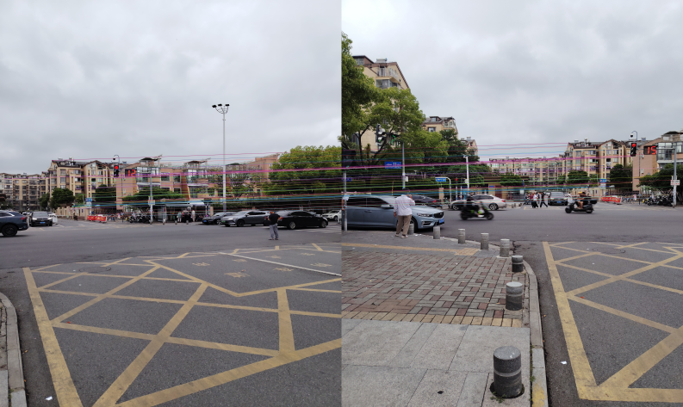
Feature Matching Result
The warpPerspective() function was used to transform and align the first image with the second image using homography transformation. Finally, both images were combined together to generate the panorama image.
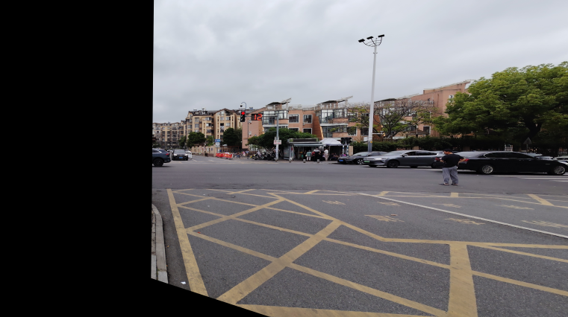
Warped Image
The final panorama image successfully combined the overlapping outdoor images into one wider scene. Some small black borders appeared due to perspective transformation during image warping.
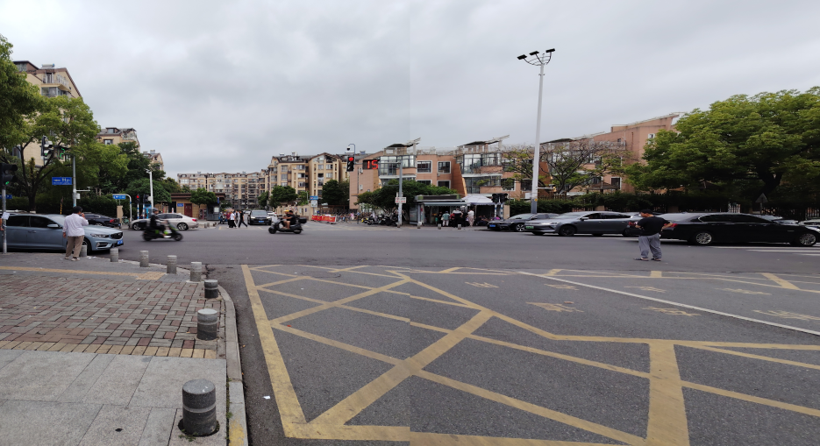
Final Panorama Image

3. Experimental Results and Discussion
The implementation of the panorama stitching process worked well through the use of ORB for feature point detection and matching, as well as the OpenCV library. It was possible to identify corresponding feature points between the two overlapping outdoor images and stitch them together to create the panorama image.
The outdoor images offered better results for panorama compared to the indoor images, since outdoor scenes have lots of feature points, such as texture details, corners, buildings, road marks and many more.
During the process of implementation, various tests were carried out with various combinations of images. Some of the indoor images did not work well to produce the right panorama, as they had less overlapping regions and lacked feature points for ORB algorithm to make a match. On the other hand, the outdoor street images resulted in improved feature matching and more stable results for the panorama stitching.
The final result for the panorama stitching process was an image consisting of the two overlapping outdoor images. There were small black boundaries on the panorama resulting from the transformation process due to image warping.
Image quality, overlapping and rich feature scenes are crucial elements for panorama stitching.

4. Conclusion
Panorama stitching in the form of images was implemented successfully using the programming language Python and OpenCV Library. In the process, ORB Feature Detection Algorithm and BFMatcher Algorithms were employed to detect and match crucial image features among overlapping images. Afterward, homography transformation and image warping were used to create a final panorama image.
Digital Image Processing concepts that were highlighted in this project include grayscale conversion, feature detection, feature matching, geometric transformation, and panorama creation.

5. Python Interpreter Environment & Tools

Software & Libraries
- Python 3.14
- OpenCV-Python 4.13.0
- NumPy 2.4.6
- Visual Studio Code (latest version)

Hardware
- Operating System: Windows 11
- RAM: 8GB
